Student Name: | Due Date: Term 1, Week 10  Wednesday 10am – Thursday 10am
Task 4: Responding

Write an analytical essay in response to one of the questions on the following page. You must refer to The Golden Age as your primary text.  Time allowed: 24 hours  Suggested length: 1000 words  Conditions: Access to notes and novel are permitted.  You must include the Student Declaration in your final submission. Plagiarism will receive no feedback. | 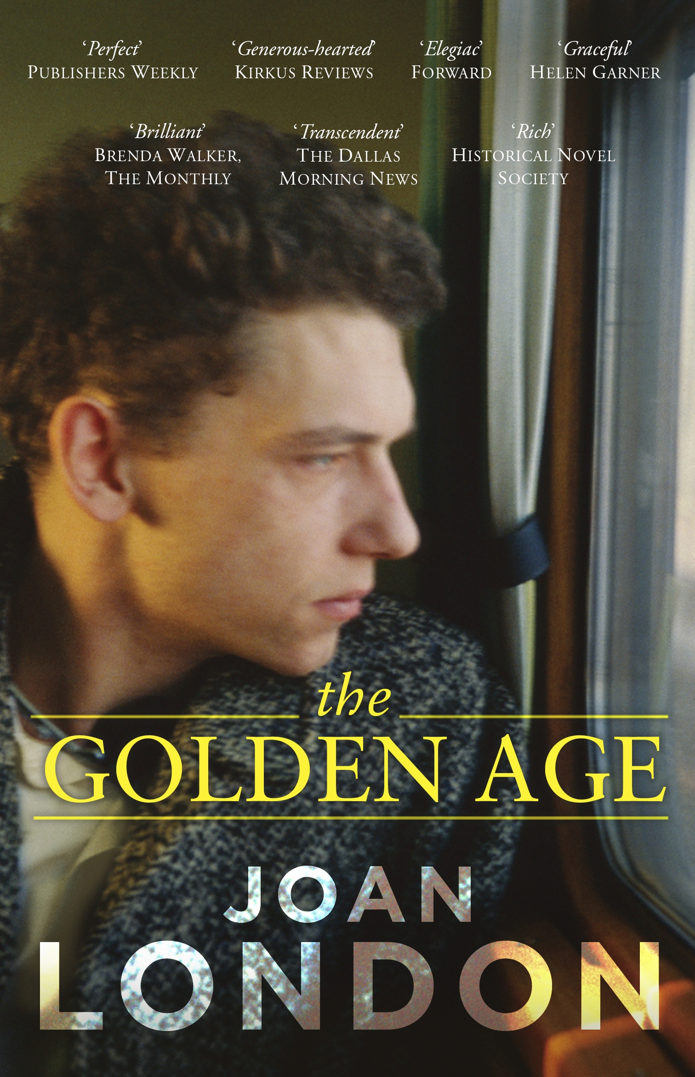

Assessment criteria (equally weighted) | Continuum
Engagement with the question | Limited ______I______l_______I______Excellent
Sustained analysis and argument | Limited ______I______l_______I______Excellent
Substantiation of argument with evidence and metalanguage | Limited ______I______l_______I______Excellent
Fluency and clarity of expression | Limited ______I______l_______I______Excellent
Teacher Comment
Working Well

Keep Working On

/100

Question 1
With reference to at least one text you have studied, explore how the author’s choice of genre works to offer a perspective on an issue.

Question 2
Discuss how effectively a text you have studied has manipulated narrative conventions to influence your response to a group of people.

Question 3
With reference to at least one text you have studied, discuss the impact of voice on the audience’s reaction to the ideas.

